 | Computer Organization and Assembly Language (EL-2003)
Semester: Fall 2025
Section: Section: BCS-3J / BCS-3K
Course Instructor: Seema Hashwani

LAB # 08
Stack Operations & Procedures

Lab Objectives:
By the end of this lab, students will be able to:

- Understand the concept and working of the Runtime Stack in assembly language and its role in function calls.
- Learn the purpose and functionality of the PUSH instruction for storing data temporarily on the stack.
- Explore the usage of the POP instruction to retrieve data from the stack efficiently.
- Understand the PROC directive and its significance in defining modular procedures in assembly language.
- Implement CALL and RET instructions to control program flow and manage procedure calls and returns.
- Develop and execute programs using nested procedures, demonstrating proper stack management and parameter passing.
- Enhance problem-solving and logical thinking skills through structured and modular assembly programming.
STACK

- LIFO (Last-In, First-Out) data structure.
- PUSH/ POP operations
- You probably have had experiences on implementing it in high-level languages.
- Here, we concentrate on runtime stack, directly supported by hardware in the
- CPU. It is essential for calling and returning from procedures.

RUNTIME STACK

Managed by the CPU, using two registers
- SS (stack segment)
- ESP (stack pointer): point the last value to be added to, or pushed on, the top of stack usually modified by instructions:
- CALL, RET, PUSH and POP

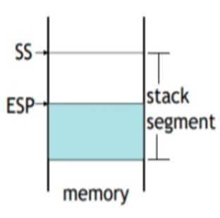

PUSH OPERATION
Push Operation A 32-bit push operation decrements the stack pointer by 4 and copies a value into the location in the stack pointed to by the stack pointer.

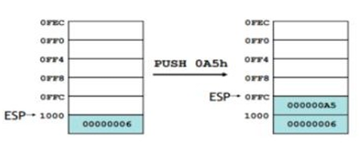

The same stack after pushing two more integers:
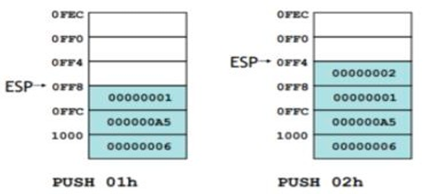

POP OPERATION
Pop Operation A pop operation removes a value from the stack. After the value is popped from the stack, the stack pointer is incremented (by the stack element size) to point to the next- highest location in the stack. It copies value at stack [ESP] into a register or variable
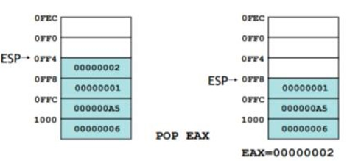

PUSH and POP INSTRUCTIONS

PUSH syntax:
- PUSH r/m16
- PUSH r/m32
- PUSH imm32

POP syntax:
- POP r/m16
- POP r/m32

EXAMPLE # 01:

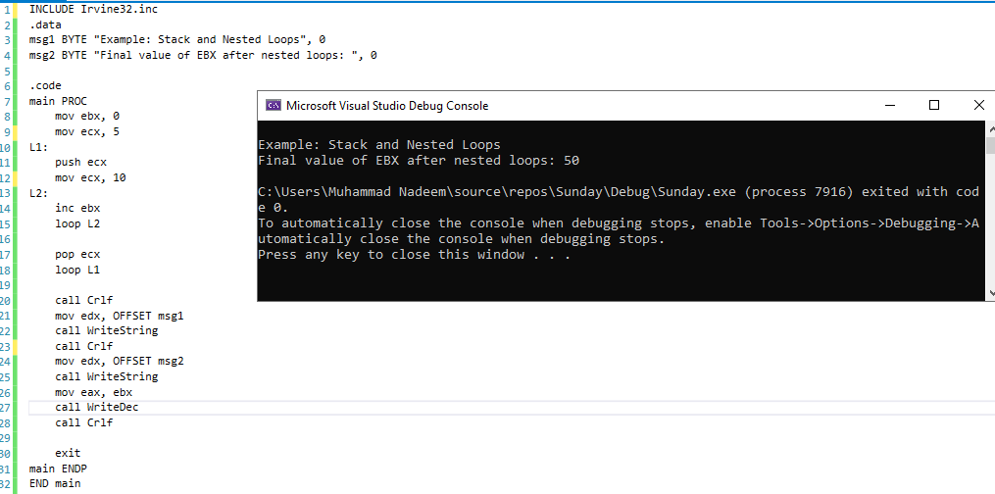
STACK AND NESTED LOOPS

EXAMPLE # 02:

HOW VALUES ARE TEMPORARILY STORED AND RETRIEVED FROM THE STACK DURING ARITHMETIC OPERATIONS.
You are a Software Engineering student developing a calculator program that needs to temporarily store intermediate results during arithmetic computations.
Write an Assembly program that:
- Pushes two numbers onto the stack.
- Pops them back one by one.
- Adds them and displays the sum.
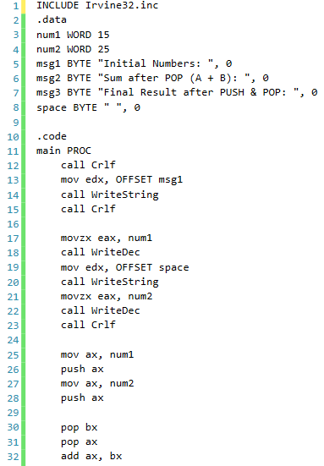
- Again pushes the result, then pops and displays it as the final stored result.
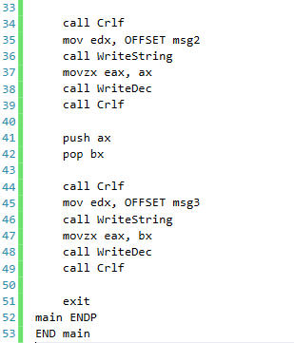

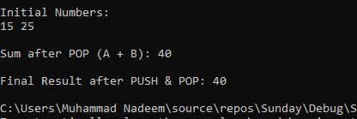

EXAMPLE # 03:

DEMONSTRATES HOW STACK-BASED MEMORY MANAGEMENT SUPPORTS REAL-WORLD FEATURES LIKE UNDO/REDO OR VERSION ROLLBACK.
REINFORCES UNDERSTANDING OF LAST-IN, FIRST-OUT (LIFO) PRINCIPLE CRUCIAL FOR RECURSION, FUNCTION CALLS, AND BACKTRACKING ALGORITHMS.

- Store 5 version numbers in an array (representing software updates).
- Push all version numbers onto the stack (latest version last).
- Pop them into another array in reverse order, simulating a rollback feature.
- Display both arrays to show before and after rollback versions.
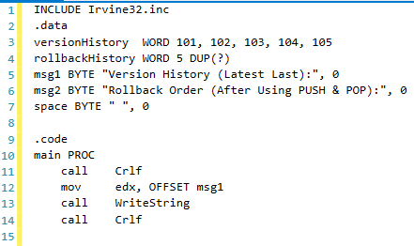
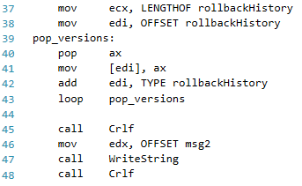
Pop all version numbers in reverse order

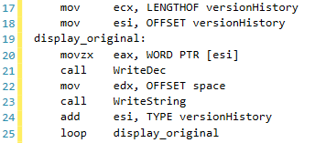
Display original version history Display rollback array (reversed)
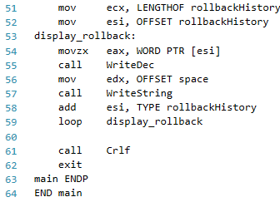

Push all version numbers to stack
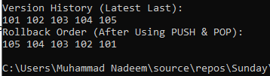
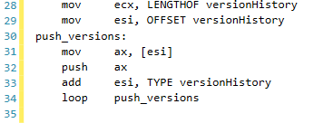

EXAMPLE # 04:

THIS PROGRAM PUSHES THREE INTEGERS ONTO THE STACK AND THEN POPS THEM TO COMPUTE THEIR PRODUCT.
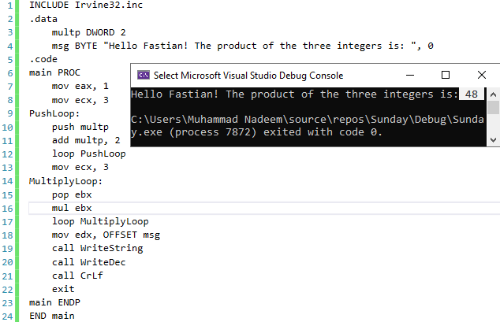

EXAMPLE # 05:

TO FIND THE LARGEST NUMBER THROUGH A STACK.
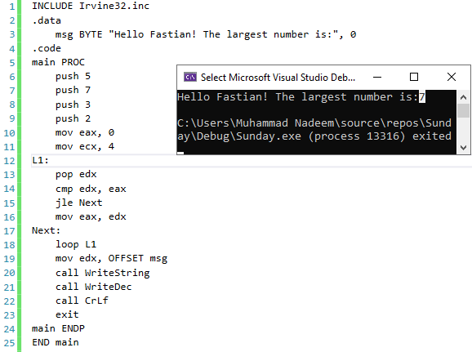
PUSHFD and POPFD INSTRUCTIONS
The MOV instruction cannot be used to copy the flags to a variable.
The PUSHFD instruction pushes the 32-bit EFLAGS register on the stack, and POPFD pops the stack into EFLAGS:
PUSHFD
POPFD

EXAMPLE # 06:

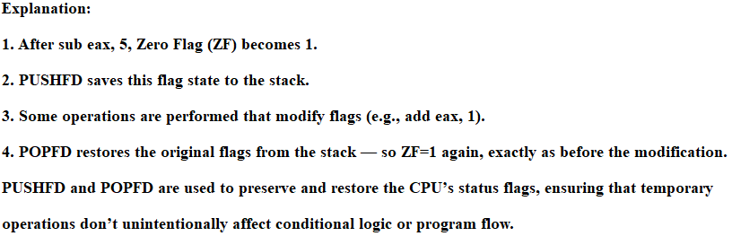
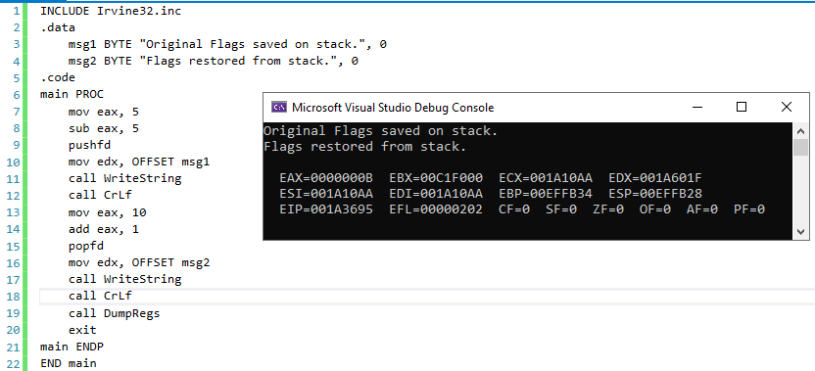
TO FIND THE LARGEST NUMBER THROUGH A STACK.

PROCEDURES
- Procedures or subroutines are very important in assembly language, as the assembly language programs tend to be large in size.
- Procedures are identified by a name. Following this name, the body of the procedure is described which performs a well-defined job.
- End of the procedure is indicated by a return statement.

PROC Directive
We can define a procedure as a named block of statements that ends in a return statement. A procedure is declared using the PROC and ENDP directives. It must be assigned a name (a valid identifier). When we create a procedure other than your program’s startup procedure, end it with a RET instruction. RET forces the CPU to return to the location from where the procedure was called:
Let us say, sample is the name of procedure.
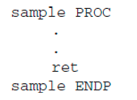

The procedure is called from another function by using the CALL instruction. The CALL instruction should have the name of the called procedure as an argument as shown below

CALL Sample
The called procedure returns the control to the calling procedure by using the RET instruction.

Call & RET INSTRUCTIONS

CALL instruction is used whenever we need to make a call to some procedure or a subprogram. Whenever a CALL is made, the following process takes place inside the microprocessor:
- The address of the next instruction that exists in the caller program (after the program CALL instruction) is stored in the stack.
- The instruction queue is emptied for accommodating the instructions of the procedure. Then, the contents of the instruction pointer (IP) is changed with the address of the first instruction of the procedure.
- The subsequent instructions of the procedure are stored in the instruction queue for execution.
- The Syntax for the CALL instruction is mentioned above.

RET instruction stands for return. This instruction is used at the end of the procedures or the subprograms. This instruction transfers the execution to the caller program. Whenever the RET instruction is called, the following process takes place inside the microprocessor:

- The address of the next instruction in the mainline program which was previously stored inside the stack is now again fetched and is placed inside the instruction pointer (IP).
- The instruction queue will now again be filled with the subsequent instructions of the mainline program.

EXAMPLE # 07:

ADD TWO NUMBERS USING PROCEDURES

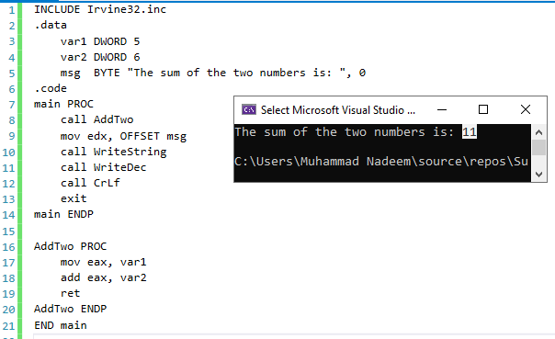

EXAMPLE # 08:

THE SUM OF INTEGERS USING PROCEDURES
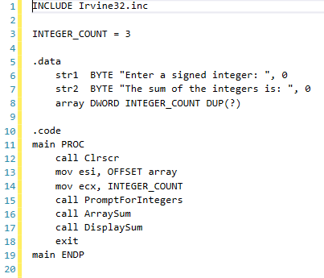
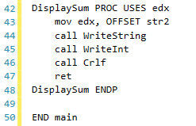

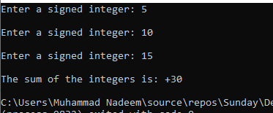
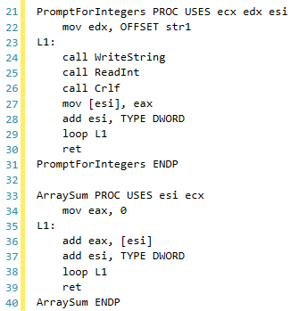

NESTED PROCEDURE CALLS

A nested procedure call occurs when a called procedure calls another procedure before the first procedure returns.
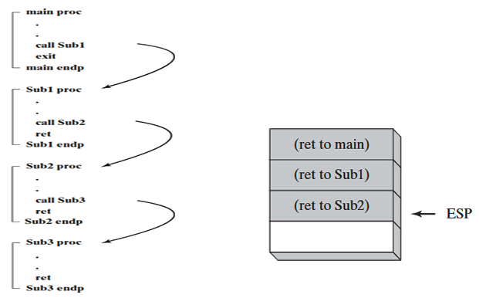

EXAMPLE # 09:

HOW NESTED PROCEDURE CALLS WORK
A nested procedure call occurs when a procedure calls another procedure before returning to the procedure that called it.
Think of it like one function calling another before finishing its own work.

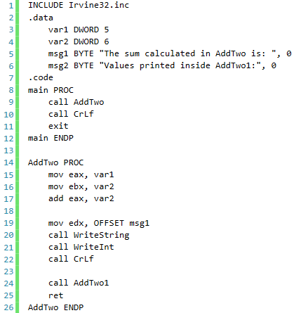
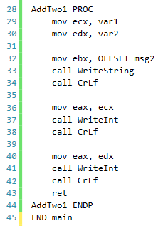

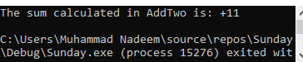

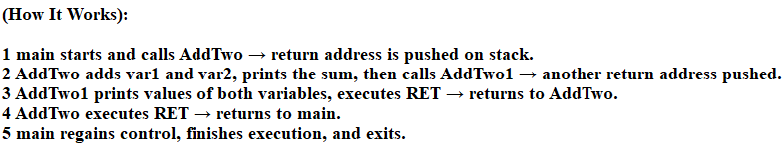

Thank you

